SOFTWARE REQUIREMENT SPECIFICATION

This documentation describes Software Requirement Specification of Capstone Online Shop Project, developed by Group 3.

**Online shop ProjectS**

Author : 2174801030070 : Huỳnh Quang An

Contents

Table List 1

Figure List 2

Revision History 3

1. Introduction 4

1.1 Purpose 4

This Software Requirement Specification provides a complete description of the features and requirements of the Shopping Online project. 4

This document is used as commitment between customer and development team about output product and development process‘s rules. 4

The expected audiences of this document are: 4

• Dr.Huynh Phuoc Danh: the customer of the project 4

• Dr.Huynh Phuoc Danh: the mentor of the project 4

• Group 3 4

1.2 Scope 4

1.3 Definition 4

1.4 Reference 4

Fundamental of Thermodynamic 4

Building Calculation & Design Software Vendors 4

5

Requirement Engineering 5

2. Functional Requirements 0

2.1 Functional Requirement list 0

2.2 Use Cases Diagram 0

2.2.1 Notations 0

2.2.2 System Overview 0

2.2.3 Manage Product 1

2.2.4 Manage Account 1

2.2.5 Manage Cart 2

2.2.6 Mange profile 4

2.2.7 Payment 4

2.2.8 Manage User Profile 4

2.2.9 Register/login 4

3. Quality Attribute 4

4. Business Rule 6

5. Constrains 6

5.1 Business constrains 6

5.2 Technical Constraint 7

5.2.1 Technical Constraint list 7

5.2.2 System requirement 7

6. Graphical User Interface Description 0

6.1 Home Page 0

6.2 Product Page 1

6.3 Product Detail Page 2

6.4 Login and Register Page 3

6.5 Information Account Page 4

6.6 Cart Page 5

6.7 Information Account Order Page 6

6.8 Payment Page 7

6.6 Information Account Order Detail Page 8

8. Printout Description 8

# Table List

Table 1 Document Revision History 3

Table 2 Functional Requirement List 1

Table 3 Priority table 1

Table 4 Complexity table 1

Table 23 Non-functional Requirement Table 5

Table 24 Business Rule table 7

Table 25 Technical Constraint table 8

Table 26 System Requirement Table 8

# Figure List

Figure 1 Notation 0

Figure 2 Use Case diagram - System Overview 1

Figure 3 Use Case diagram - Manage Project 2

Figure 4 Use Case diagram - Manage Item 3

Figure 6 Main Application Screen 0

Figure 7 New Project Screen 1

Figure 8 New Folder Screen 1

Figure 9 New Item Regions 2

Figure 10 Item Dependency Screen 3

Figure 11 Module Management 4

# Revision History

2024

|  |  |  |  |
| --- | --- | --- | --- |
| **Date** | **Revision** | **Description** | **Revised by** |
| **5/6/2024** | 1.0 | Create SRS template | Huynh Quang An |
| **5/6/2024** | 1.1 | SRS foundation | Huynh Quang An |
| **5/6/2024** | 1.2 | Update Introduction | Huynh Quang An |
| **5/6/2024** | 1.4 | Update use case table description and business rule | Huynh Quang An |
| **5/6/2024** | 1.5 | Update use case description | Huynh Quang An |
| **6/6/2024** | 1.6 | Update technical constraint and quality attribute | Huynh Quang An |
| **7/6/2024** | 2.0 | Update function requirements, use case diagram, use case description, business rule | Huynh Quang An |
| **? /6/2024** | 2.1 | Update GUI | Huynh Quang An |
| **8/6/2024** | 3.0 | Update Final | Huynh Quang An |
| **10/6/2024** | 3.1 | Update GUI | Huynh Quang An |
| **11/6/2024** | 3.1 | Update Quality Attribute | Huynh Quang An |
| **12/6/2024** | 4.0 | Update Final | Huynh Quang An |

Table 1 Document Revision History

# 1. Introduction

2024

## 1.1 Purpose

## This Software Requirement Specification provides a complete description of the features and requirements of the Shopping Online project.

## This document is used as commitment between customer and development team about output product and development process‘s rules.

## The expected audiences of this document are:

## Dr.Huynh Phuoc Danh: the customer of the project

## Dr.Huynh Phuoc Danh: the mentor of the project

## Group 3

## 1.2 Scope

Shopping Online project provides software support for following works:

* User behavior analysis: Collect and analyze customer purchasing behavior.
* Optimize user experience: Improve interface and customize product suggestions.
* Warehouse and inventory management: Track and forecast inventory.
* Payment and delivery processing: Integrate online payments and delivery management.
* Security and data protection: Ensure information security and online transactions.
* Search engine optimization and marketing: Increase online marketing performance.

## 1.3 Definition

* **Use SQL Server :** to store sales data.Library
* **Use ReactJS:** to build the website's user interface.
* **Use Nodejs framework :** to interact with Backend and database

## 1.4 Reference

### Fundamental of Thermodynamic

* ReactJS : <https://reactjs.org/>
* Mozilla Developer Network (MDN) JavaScript Documentation: <https://developer.mozilla.org/en-US/docs/Web/JavaScript>
* <https://github.com/>
* <https://www.figma.com/>
* SQL Server home page: <https://www.microsoft.com/en-us/sql-serverK>
* <https://spring.io/projects/spring-boot>

### Building Calculation & Design Software Vendors

* Figma , Visual Code , Github , SQL Sever

### 

2024

### Requirement Engineering

* Identify stakeholders , Collect requirements , Analyze and classify requirements , Document requirements (SRS) , Agreement and approval of request.

# 2. Functional Requirements

## 2.1 Functional Requirement list

|  |  |  |  |  |
| --- | --- | --- | --- | --- |
| **ID** | **Name** | **Description** | **Priority** | **Levels of complexity** |
| **MP** | Manage Product | Program allows admin add, view, edit, remove product in website | 1 | 2 |
| **MP.1** | Add product | Program allows admin add new product | 1 | 3 |
| **MP.2** | View product | Program allows admin view list info about product | 1 | 3 |
| **MP.3** | Edit product | Program allows admin edit product | 1 | 3 |
| **MP.4** | Remove product | Program allows admin remove product | 1 | 3 |
| **MA** | Manage Account | Program allows admin add, edit , remove, view info accounts | **1** | **2** |
| **MA.1** | Add account | Program allows admin add new account | **2** | **3** |
| **MA.2** | Edit account | Program allows admin edit account | **1** | **3** |
| **MA.3** | Remove account | Program allows admin remove account | **1** | **3** |
| **MA.4** | View account | Program allows admin view list account and info detail of account | **1** | **3** |
| **MC** | Manage Cart | Program allows user add , remove , edit , view product | **1** | **2** |
| **MM.1** | Add Product Cart | Program allows user add product to cart | **1** | **2** |
| **MM.2** | Remove Product Cart | Program allows user add product to cart | **1** | **2** |
| **MM.3** | Edit Product Cart | Program allows user remove from cart | **1** | **2** |
| **MM.4** | View Product Cart | Program show list product in cart | **1** | **2** |
| **Pay** | Payments | Program allows user pay for product with varios method ( ePay , Bank , COD) | **1** | **1** |
| **MUI** | Change User Info | Program allows user edit , remove , add , view info user’s account | **1** | **3** |
| **MUI.1** | Add Info | Program allows user add new info | **2** | **3** |
| **MUI.2** | Edit Info | Program allows user edit account info | **1** | **3** |
| **MUI.3** | Remove Info | Program allows user remove info | **1** | **3** |
| **MUI.4** | View Info | Program show all info detail of account | **1** | **3** |
| **SP** | Search Product | Program allows user search and filter product | **1** | **3** |

Table 2 Functional Requirement List

2024

|  |  |
| --- | --- |
| **Level** | **Description** |
| **1** | Must do |
| **2** | Should be |
| **3** | Depends on |
| **4** | Should not |

Table 3 Priority table

|  |  |
| --- | --- |
| **Level** | **Description** |
| **1** | Extremely complex |
| **2** | Very complex |
| **3** | Normal |
| **4** | Easy |
| **5** | Extremely easy |

Table 4 Complexity table

## 2.2 Use Cases Diagram

### 2.2.1 Notations

|  |  |  |
| --- | --- | --- |
| **Construct** | **Description** | **Syntax** |
| **Actor** | A coherent set of roles that users of use cases play when interacting with these use cases. |  |
| **Use case** | A sequence of actions, including variants, that a system (or other entity) can perform, interacting with actors of the system. |  |
| **System Boundary** | Represents the boundary between the physical system and the actors who interact with the physical system. |  |
| **Association** | The participation of an actor in a use case. i.e., instance of an actor and of use cases communicating with each other. |  |
| **Generalization** | A taxonomic relationship between a more general use case and a more specific use case. |  |
| **Extend** | Specify that one use cases extend the definition of other specify conditions | 1 |

Figure 1 Notation

### 2.2.2 System Overview

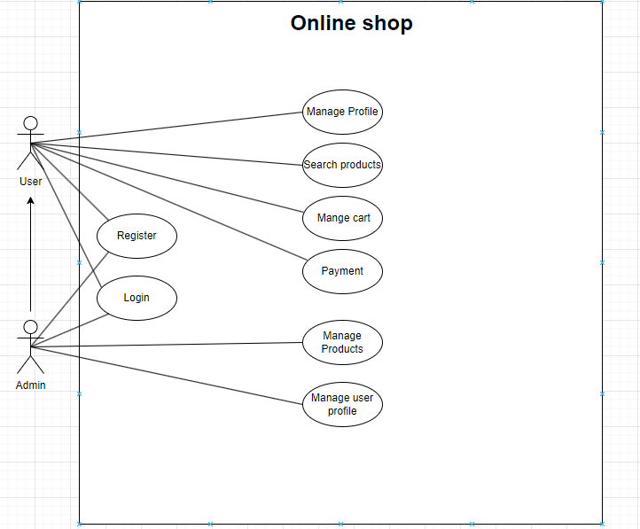

2024

Figure 2 Use Case diagram - System Overview

### 

### 2.2.3 Manage Product

Figure 3 Use Case diagram - Manage Product

### 2.2.4 Manage Account

Figure 4 Use Case diagram - Manage products

### 2.2.5 Manage Cart

2024

Figure 5 Use case Diagram - Manage Cart

### 2.2.6 Mange profile

2024

Figure 5 Use case Diagram - Manage profile

### 2.2.7 Payment

Figure 5 Use case Diagram – Payment

Figure 5 Use case Diagram – Login

### 2.2.8 Manage User Profile

Figure 5 Use case Diagram - Manage user profile

### 2.2.9 Register/login

Figure 5 Use case Diagram – Register

# 3. Quality Attribute

Here is the common non-functional requirement for main application and modules. The other specific non-functional requirement of each module will be different.

|  |  |  |  |
| --- | --- | --- | --- |
| **ID** | **Quality** | **Attribute** | **Description** |
| **QA.M.F.1** | Modifiability | Flexibility | Allow configuration the number of modules to meet the firms process and business |
| **QA.M.F.2** | Modifiability | Flexibility | Diverse payment methods on e-wallets |
| **QA.M.C.3** | Modifiability | Consistency | After changing the software, the website still functions properly and is consistent in results |
| **QA.M.E.4** | Modifiability | Extensibility | Have ability to extend to number of modules in the application. |
| **QA.M.U.5** | Modifiability | Usability | Full functions to use |
| **QA.M.S.6** | Modifiability | Scalability | Allow load many module in many way without exceed the latency rate & slow down the application |
| **QA.P.L.7** | Performance | Latency | The ability to display necessary information of the website is in less than 5 seconds. |
| **QA.P.E.8** | Performance | Efficiency | Website performance is optimized, does not create a burden on hardware |
| **QA.U.L.9** | Usability | Learnability | The website needs to have a simple, easy-to-use and user-friendly user interface |
| **QA.S.C.10** | Security | Correctness | User's personal and payment information is protected |
| **QA.R.C.11** | Reliability | Correctness | The information is calculated accurately with reality |
| **QA.A.F.12** | Accessibility | Flexibility | Easily accessible from any device |

Table 23 Non-functional Requirement Table

# 4. Business Rule

2024

|  |  |
| --- | --- |
| **ID** | **Content** |
| **01** | * Product price cannot be lower than cost price. * Product quantity in stock cannot be less than 0. * Product description must be clear and contain full information. |
| **02** | * The number of products in the cart cannot exceed the stock quantity * Customers can save their cart for later shopping. |
| **03** | * Support popular payment methods (cash, bank transfer, credit card). * The system must ensure the security of payment transactions |
| **08** | * User passwords must be kept secure * Users can change their account information |
| **09** | * + The system must display accurate and fast search results.   + The system must support searching by product name, category, price. |

Table 24 Business Rule table

# 5. Constrains

## 5.1 Business constrains

* 3 peoples
* 30 weeks

## 5.2 Technical Constraint

2024

## 5.2.1 Technical Constraint list

|  |  |
| --- | --- |
| **Consideration** | **Technical Constraints** |
| **Computer Operating System** | Windows , MacOS |
| **Computer platform** | Intel based processor |
| **Computer languages** | None |
| **Peripheral or network hardware** | None |
| **Commercial hardware or software products** | None |
| **Tools and method** | None |
| **Protocols, interfaces, standards** | .NET 4.0 |
| **Legacy hardware and software** | None |

Table 25 Technical Constraint table

## 5.2.2 System requirement

|  |  |
| --- | --- |
| Component | Requirement |
| **Computer and processor** | Computer that has a 1.6GHz or faster processor |
| **Memory** | 512 megabyte (MB) RAM or higher |
| **Hard disk** | 1 gigabyte (GB); 5400 RPM hard disk drive; a portion of this disk space will be freed after installation if the original download package is removed from the hard drive. |
| **Drive** | CD-ROM or DVD drive |
| **Display** | DirectX 9 capable video card running at 1024 x 768 or higher-resolution display |
| **Operating system** | Microsoft Windows XP with Service Pack (SP) 2, Windows Server 2003 with SP1, or later operating system |
| **Other** |  |
| **Additional** | Actual requirements and product functionality may vary based on your system configuration and operating system. |

Table 26 System Requirement Table

# 6. Graphical User Interface Description

## 6.1 Home Page

Figure 6 Home Page

## 6.2 Product Page

2024

Figure 7 Product Page

## 6.3 Product Detail Page

Figure 8 Product Detail Page

## 6.4 Login and Register Page

2024

Figure 9 Login and Register Page

## 6.5 Information Account Page

2024

Figure 10 Information Account Page

## 6.6 Cart Page

2024

Figure 11 Cart Page

## 6.7 Information Account Order Page

2024

Figure 11 Information Account Order Page

## 6.8 Payment Page

2024

Figure 11 Payment Page

## 6.6 Information Account Order Detail Page

2024

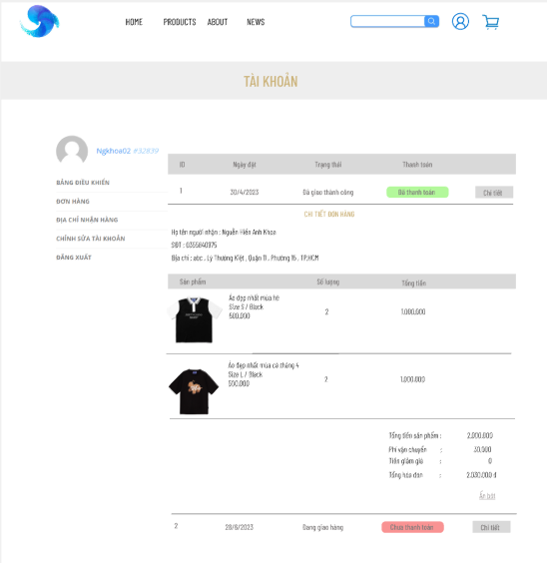

Figure 11 Information Account Detail Order Page

# 8. Printout Description

Please refer to Printout list in the specific module description, the main application has no printout.

--The end --